Group Report

Introduction to Artificial Intelligence

**Group 18**

Zdravka Rangelova Dimitrova

Mathias Elbæk Gregersen

Michael Jakob

**Robot design**

How to follow a line…

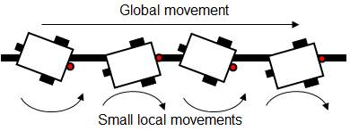

**Software architecture**

Layers…